**Dr. Leonid Kogan**

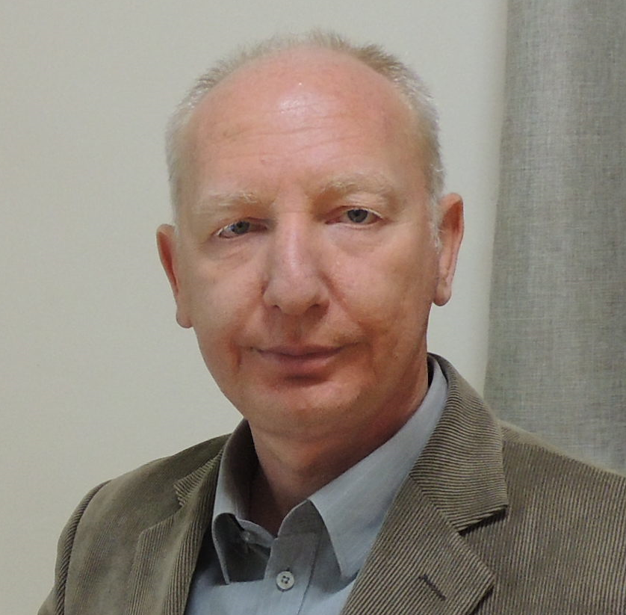

Born in Samarkand, Uzbekistan. His parents came

from the Ukraine and Byelorussia. Married to Elena

Kogan and father of 2 children. Dr Kogan founded the

plastic surgery and burns unit at the Galilee Medical

Center in 2000.

After graduating high school with the highest honors, he attended Samarkand medical school which he also graduated with excellence.

He did a two year residency in general surgery, after which he began working in one of the surgery departments in Samarkand.

In 1986 he moved to Moscow and after a short time working in local city hospitals, and passing the admissions exam, he began working in Vishnevsky national surgical center, Moscow, Russia.

Working in the national burn center, he divided his time between treating burn patients and clinical research. Within 3 years Dr Kogan finished his thesis and received his PhD.

After immigrating to Israel with his family In 1991, Dr Kogan, and in order to continue his work with burn patients, Dr Kogan started his residency in plastic surgery. After a brief exposure to the new profession he took great interest in it. Upon completing his residency in Hadassah Medical Center in Jerusalem, Israel, he moved to the Galilee Medical Center and developed the field of plastic surgery here.

He founded the plastic surgery and burns unit, and since 2014 this unit is accredited for residency.